Sources:

CISC190 Java Programming

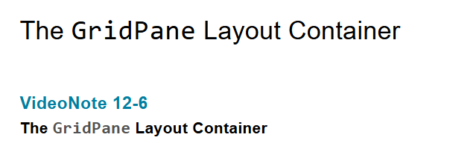

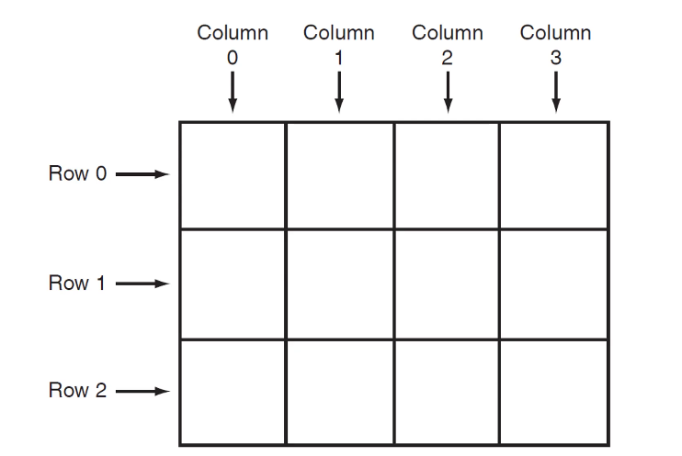

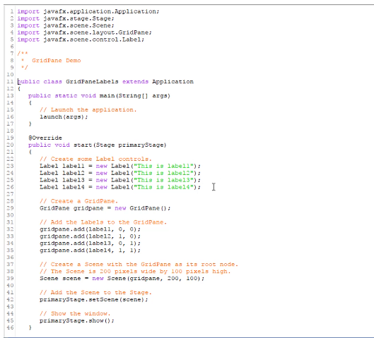

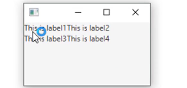

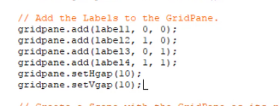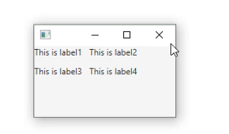

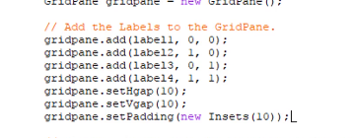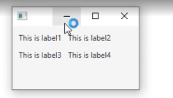

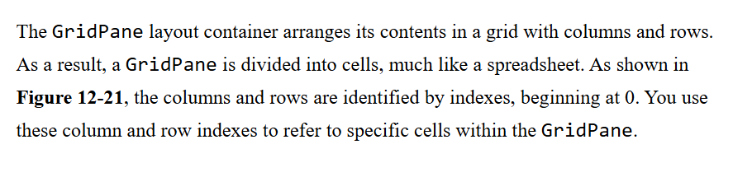

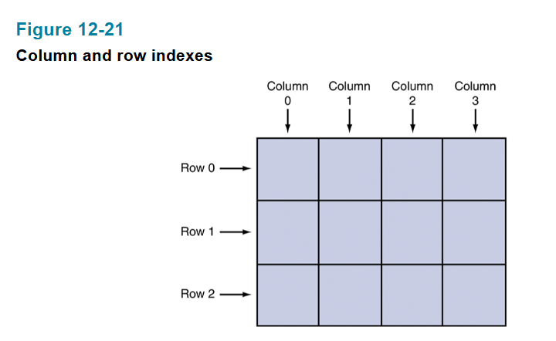

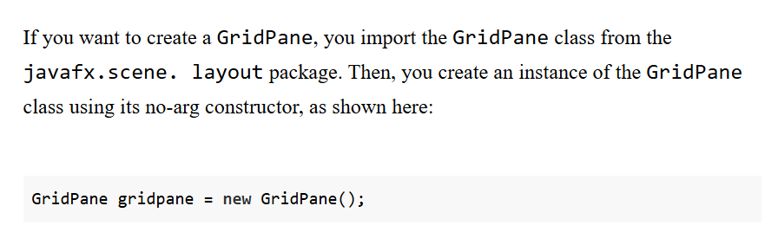

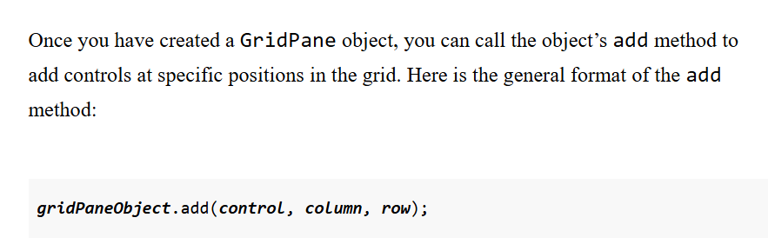

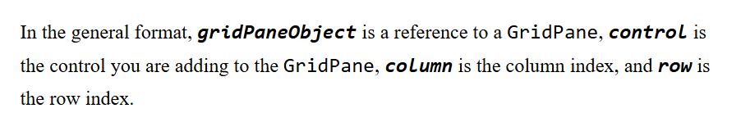

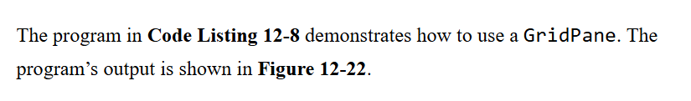

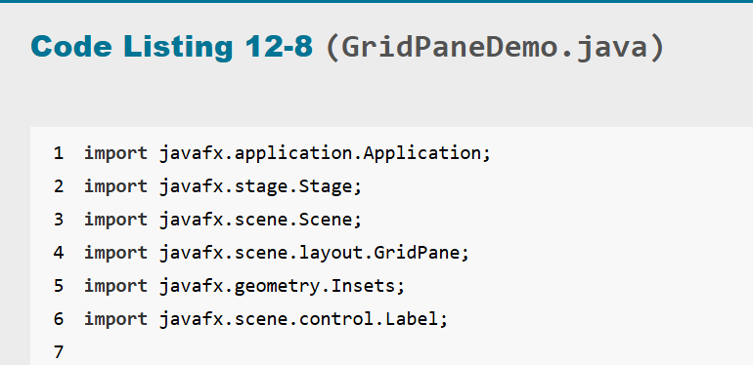



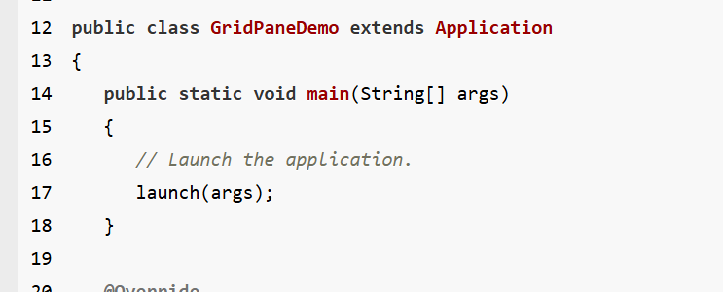



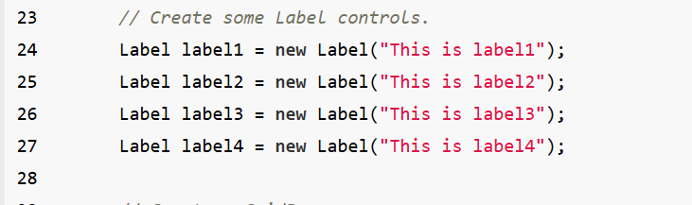



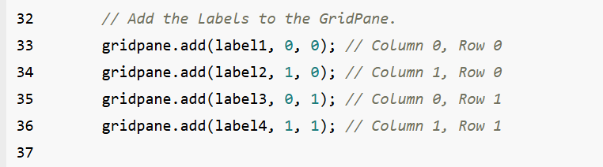

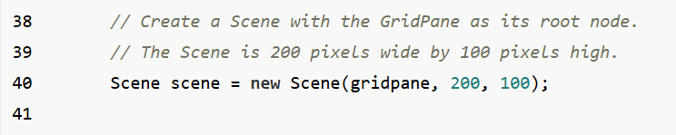

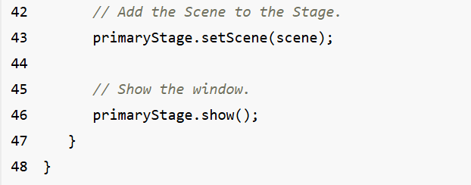

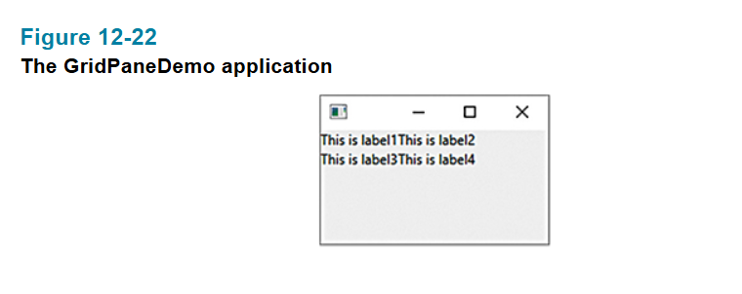

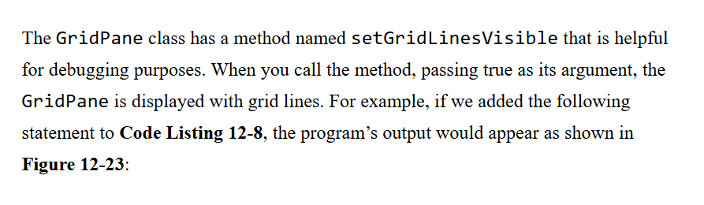

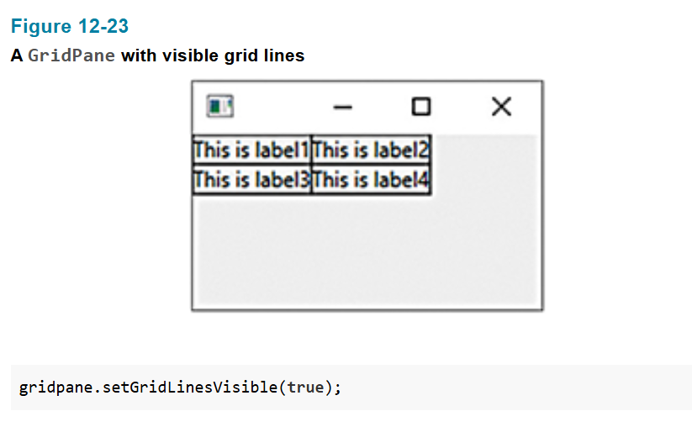

Ex:

package application;

import javafx.application.Application;

import javafx.stage.Stage;

import javafx.scene.Scene;

import javafx.scene.layout.HBox;

import javafx.scene.layout.VBox;

import javafx.scene.layout.GridPane;

import javafx.scene.image.Image;

import javafx.scene.image.ImageView;

import javafx.geometry.Insets;

import javafx.geometry.Pos;

import javafx.scene.control.Button;

public class Main extends Application {

public static void main(String[] args) {

launch(args);

}

@Override

public void start(Stage primaryStage) {

Button button1 = new Button("🏠 HOME");

Button button2 = new Button("≡ Menu");

Image image = new Image("file:C:\\Users\\0005766060\\eclipse-workspace\\JavaFXProject\\wallpaper1.jpg");

Image image2 = new Image("file:C:\\Users\\0005766060\\eclipse-workspace\\JavaFXProject\\wallpaper2.jpg");

Image image3 = new Image("file:C:\\Users\\0005766060\\eclipse-workspace\\JavaFXProject\\wallpaper3.jpg");

Image image4 = new Image("file:C:\\Users\\0005766060\\eclipse-workspace\\JavaFXProject\\wallpaper1.jpg");

Image image5 = new Image("file:C:\\Users\\0005766060\\eclipse-workspace\\JavaFXProject\\wallpaper2.jpg");

Image image6 = new Image("file:C:\\Users\\0005766060\\eclipse-workspace\\JavaFXProject\\wallpaper3.jpg");

ImageView imageView = new ImageView(image);

ImageView imageView2 = new ImageView(image2);

ImageView imageView3 = new ImageView(image3);

ImageView imageView4 = new ImageView(image4);

ImageView imageView5 = new ImageView(image5);

ImageView imageView6 = new ImageView(image6);

imageView.setFitWidth(500);

imageView.setFitHeight(500);

imageView.setPreserveRatio(true);

imageView2.setFitWidth(500);

imageView2.setFitHeight(500);

imageView2.setPreserveRatio(true);

imageView3.setFitWidth(500);

imageView3.setFitHeight(500);

imageView3.setPreserveRatio(true);

imageView4.setFitWidth(500);

imageView4.setFitHeight(500);

imageView4.setPreserveRatio(true);

imageView5.setFitWidth(500);

imageView5.setFitHeight(500);

imageView5.setPreserveRatio(true);

imageView6.setFitWidth(500);

imageView6.setFitHeight(500);

imageView6.setPreserveRatio(true);

VBox vbox = new VBox(10,button1, button2);

vbox.setPadding(new Insets(30));

GridPane gridPane = new GridPane();

gridPane.add(imageView, 0, 0);

gridPane.add(imageView2, 1, 0);

gridPane.add(imageView3, 2, 0);

gridPane.add(imageView4, 0, 1);

gridPane.add(imageView5, 1, 1);

gridPane.add(imageView6, 2, 1);

gridPane.setGridLinesVisible(true);

//HBox hbox = new HBox(10,vbox,imageView,imageView2,imageView3);

//hbox.setPadding(new Insets(50));

//Scene scene = new Scene(hbox);

Scene scene = new Scene(gridPane);

primaryStage.setScene(scene);

primaryStage.setTitle("GUI Program");

primaryStage.show();

}

}

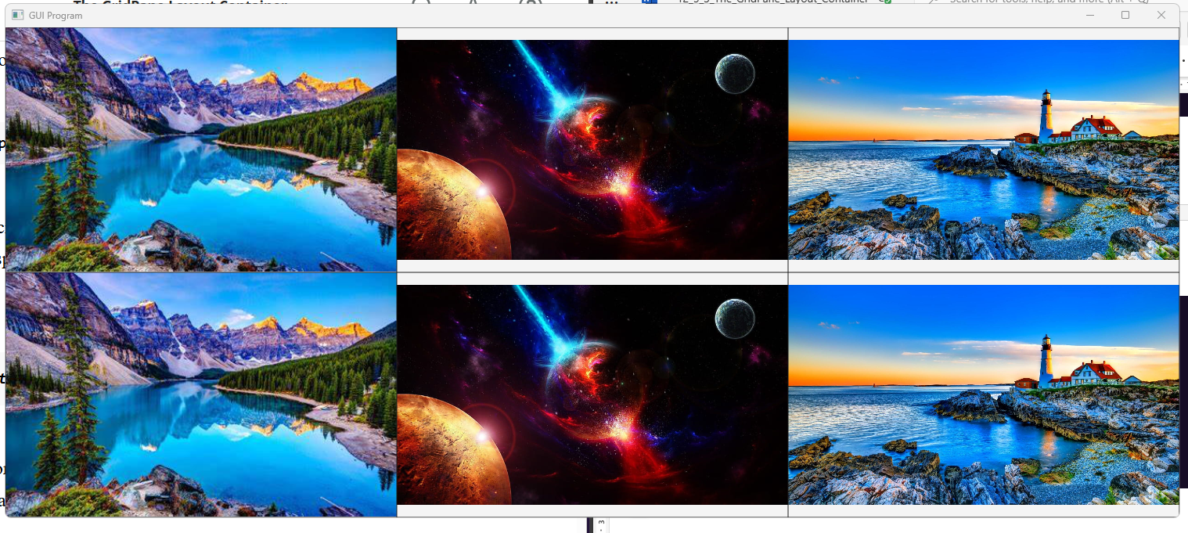

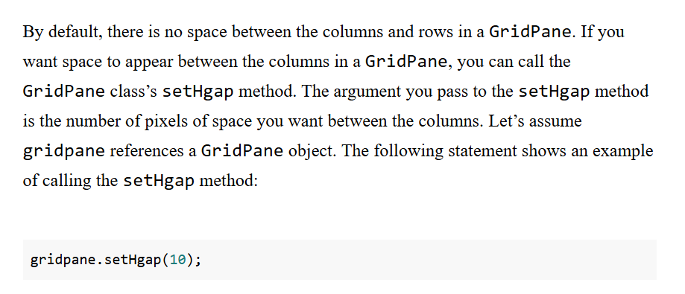

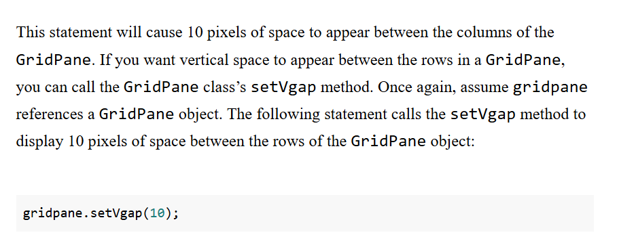

Ex:

package application;

import javafx.application.Application;

import javafx.stage.Stage;

import javafx.scene.Scene;

import javafx.scene.layout.HBox;

import javafx.scene.layout.VBox;

import javafx.scene.layout.GridPane;

import javafx.scene.image.Image;

import javafx.scene.image.ImageView;

import javafx.geometry.Insets;

import javafx.geometry.Pos;

import javafx.scene.control.Button;

public class Main extends Application {

public static void main(String[] args) {

launch(args);

}

@Override

public void start(Stage primaryStage) {

Button button1 = new Button("🏠 HOME");

Button button2 = new Button("≡ Menu");

Image image = new Image("file:C:\\Users\\0005766060\\eclipse-workspace\\JavaFXProject\\wallpaper1.jpg");

Image image2 = new Image("file:C:\\Users\\0005766060\\eclipse-workspace\\JavaFXProject\\wallpaper2.jpg");

Image image3 = new Image("file:C:\\Users\\0005766060\\eclipse-workspace\\JavaFXProject\\wallpaper3.jpg");

Image image4 = new Image("file:C:\\Users\\0005766060\\eclipse-workspace\\JavaFXProject\\wallpaper1.jpg");

Image image5 = new Image("file:C:\\Users\\0005766060\\eclipse-workspace\\JavaFXProject\\wallpaper2.jpg");

Image image6 = new Image("file:C:\\Users\\0005766060\\eclipse-workspace\\JavaFXProject\\wallpaper3.jpg");

ImageView imageView = new ImageView(image);

ImageView imageView2 = new ImageView(image2);

ImageView imageView3 = new ImageView(image3);

ImageView imageView4 = new ImageView(image4);

ImageView imageView5 = new ImageView(image5);

ImageView imageView6 = new ImageView(image6);

imageView.setFitWidth(500);

imageView.setFitHeight(500);

imageView.setPreserveRatio(true);

imageView2.setFitWidth(500);

imageView2.setFitHeight(500);

imageView2.setPreserveRatio(true);

imageView3.setFitWidth(500);

imageView3.setFitHeight(500);

imageView3.setPreserveRatio(true);

imageView4.setFitWidth(500);

imageView4.setFitHeight(500);

imageView4.setPreserveRatio(true);

imageView5.setFitWidth(500);

imageView5.setFitHeight(500);

imageView5.setPreserveRatio(true);

imageView6.setFitWidth(500);

imageView6.setFitHeight(500);

imageView6.setPreserveRatio(true);

VBox vbox = new VBox(10,button1, button2);

vbox.setPadding(new Insets(30));

GridPane gridPane = new GridPane();

gridPane.add(imageView, 0, 0);

gridPane.add(imageView2, 1, 0);

gridPane.add(imageView3, 2, 0);

gridPane.add(imageView4, 0, 1);

gridPane.add(imageView5, 1, 1);

gridPane.add(imageView6, 2, 1);

gridPane.setGridLinesVisible(true);

//HBox hbox = new HBox(10,vbox,imageView,imageView2,imageView3);

//hbox.setPadding(new Insets(50));

//Scene scene = new Scene(hbox);

gridPane.setHgap(20);

gridPane.setVgap(20);

Scene scene = new Scene(gridPane);

primaryStage.setScene(scene);

primaryStage.setTitle("GUI Program");

primaryStage.show();

}

}

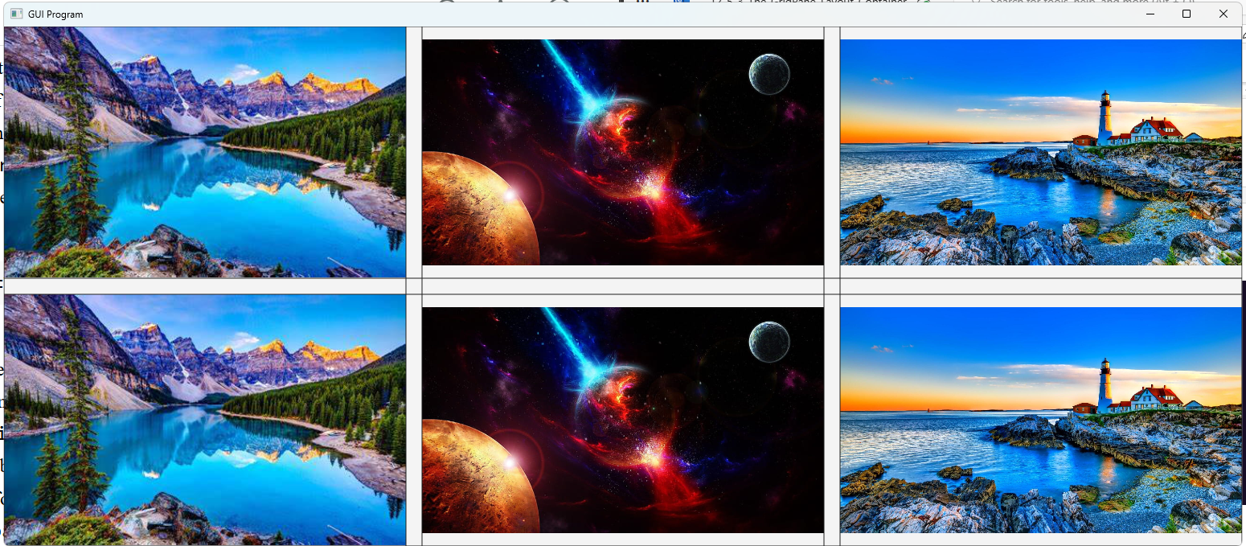

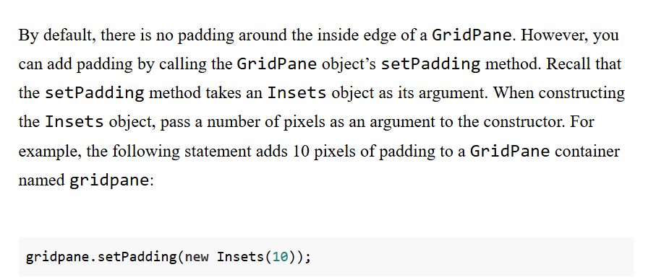

package application;

import javafx.application.Application;

import javafx.stage.Stage;

import javafx.scene.Scene;

import javafx.scene.layout.HBox;

import javafx.scene.layout.VBox;

import javafx.scene.layout.GridPane;

import javafx.scene.image.Image;

import javafx.scene.image.ImageView;

import javafx.geometry.Insets;

import javafx.geometry.Pos;

import javafx.scene.control.Button;

public class Main extends Application {

public static void main(String[] args) {

launch(args);

}

@Override

public void start(Stage primaryStage) {

Button button1 = new Button("🏠 HOME");

Button button2 = new Button("≡ Menu");

Image image = new Image("file:C:\\Users\\0005766060\\eclipse-workspace\\JavaFXProject\\wallpaper1.jpg");

Image image2 = new Image("file:C:\\Users\\0005766060\\eclipse-workspace\\JavaFXProject\\wallpaper2.jpg");

Image image3 = new Image("file:C:\\Users\\0005766060\\eclipse-workspace\\JavaFXProject\\wallpaper3.jpg");

Image image4 = new Image("file:C:\\Users\\0005766060\\eclipse-workspace\\JavaFXProject\\wallpaper1.jpg");

Image image5 = new Image("file:C:\\Users\\0005766060\\eclipse-workspace\\JavaFXProject\\wallpaper2.jpg");

Image image6 = new Image("file:C:\\Users\\0005766060\\eclipse-workspace\\JavaFXProject\\wallpaper3.jpg");

ImageView imageView = new ImageView(image);

ImageView imageView2 = new ImageView(image2);

ImageView imageView3 = new ImageView(image3);

ImageView imageView4 = new ImageView(image4);

ImageView imageView5 = new ImageView(image5);

ImageView imageView6 = new ImageView(image6);

imageView.setFitWidth(500);

imageView.setFitHeight(500);

imageView.setPreserveRatio(true);

imageView2.setFitWidth(500);

imageView2.setFitHeight(500);

imageView2.setPreserveRatio(true);

imageView3.setFitWidth(500);

imageView3.setFitHeight(500);

imageView3.setPreserveRatio(true);

imageView4.setFitWidth(500);

imageView4.setFitHeight(500);

imageView4.setPreserveRatio(true);

imageView5.setFitWidth(500);

imageView5.setFitHeight(500);

imageView5.setPreserveRatio(true);

imageView6.setFitWidth(500);

imageView6.setFitHeight(500);

imageView6.setPreserveRatio(true);

VBox vbox = new VBox(10,button1, button2);

vbox.setPadding(new Insets(30));

GridPane gridPane = new GridPane();

gridPane.add(imageView, 0, 0);

gridPane.add(imageView2, 1, 0);

gridPane.add(imageView3, 2, 0);

gridPane.add(imageView4, 0, 1);

gridPane.add(imageView5, 1, 1);

gridPane.add(imageView6, 2, 1);

gridPane.setGridLinesVisible(true);

//HBox hbox = new HBox(10,vbox,imageView,imageView2,imageView3);

//hbox.setPadding(new Insets(50));

//Scene scene = new Scene(hbox);

gridPane.setHgap(20);

gridPane.setVgap(20);

gridPane.setPadding(new Insets(20));

Scene scene = new Scene(gridPane);

primaryStage.setScene(scene);

primaryStage.setTitle("GUI Program");

primaryStage.show();

}

}

